**WEEK 6**

**REACT**

**IMPORTANT ADDITIONAL HANDS ON**

**6) TrainersApp**

Trainer.jsx

class Trainer {

  constructor(trainerId, name, email, phone, technology, skills) {

    this.trainerId = trainerId;

    this.name = name;

    this.email = email;

    this.phone = phone;

    this.technology = technology;

    this.skills = skills;

  }

}

export default Trainer;

trainerDetails.jsx

import React from 'react';

import { useParams } from 'react-router-dom';

import trainersMock from './TrainersMock';

function TrainerDetail() {

  const { id } = useParams(); //

  // 🔍 find the trainer with matching id

  const trainer = trainersMock.find(t => t.trainerId === id);

  if (!trainer) {

    return <h2>Trainer not found</h2>;

  }

  return (

    <div>

      <h2>{trainer.name}'s Profile</h2>

      <p><strong>Email:</strong> {trainer.email}</p>

      <p><strong>Phone:</strong> {trainer.phone}</p>

      <p><strong>Technology:</strong> {trainer.technology}</p>

      <p><strong>Skills:</strong> {trainer.skills.join(', ')}</p>

    </div>

  );

}

export default TrainerDetail;

trainerlist.jsx

import React from 'react';

import { Link } from 'react-router-dom';

function TrainersList({ trainers }) {

  return (

    <div>

      <h2>Trainers List</h2>

      <ul>

        {trainers.map((trainer) => (

          <li key={trainer.trainerId}>

            <Link to={`/trainers/${trainer.trainerId}`}>

              {trainer.name}

            </Link>

          </li>

        ))}

      </ul>

    </div>

  );

}

export default TrainersList;

trainersMock.jsx

import Trainer from "./trainer";

const trainersMock = [

  new Trainer(

    't-syed8',

    'Syed Khaleelullah',

    'khaleelullah@cognizant.com',

    '97676516962',

    '.NET',

    ['C#', 'SQL Server', 'React', '.NET Core']

  ),

  new Trainer(

    't-jojo',

    'Jojo Jose',

    'jojo@cognizant.com',

    '9897199231',

    'Java',

    ['Java', 'JSP', 'Angular', 'Spring']

  ),

  new Trainer(

    't-elisa',

    'Elisa Jones',

    'elisa@cognizant.com',

    '9871212235',

    'Python',

    ['Python', 'Django', 'Angular']

  )

];

export default trainersMock;

app.jsx

import React from 'react';

import { BrowserRouter, Routes, Route, Link } from 'react-router-dom';

import Home from './Home';

import TrainersList from './Trainerlist';

import TrainerDetail from './TrainerDetails';

import trainersMock from './TrainersMock';

function App() {

  return (

    <BrowserRouter>

      <div style={{ padding: '20px', fontFamily: 'Arial' }}>

        <nav style={{ marginBottom: '20px' }}>

          <Link to="/" style={{ marginRight: '20px' }}>Home</Link>

          <Link to="/trainers">Trainers</Link>

        </nav>

        <Routes>

          <Route path="/" element={<Home />} />

          <Route path="/trainers" element={<TrainersList trainers={trainersMock} />} />

          <Route path="/trainers/:id" element={<TrainerDetail />} /> {/* ✅ New Route */}

        </Routes>

      </div>

    </BrowserRouter>

  );

}

export default App;

home.jsx

import React from 'react';

function Home() {

  return (

    <div>

      <h1>Welcome to TrainersApp</h1>

      <p>This application helps you manage and view Cognizant trainers’ information.</p>

      <ul>

        <li>View list of available trainers</li>

        <li>Check trainer details and skills</li>

        <li>Organized by technology specialization</li>

      </ul>

    </div>

  );

}

export default Home;

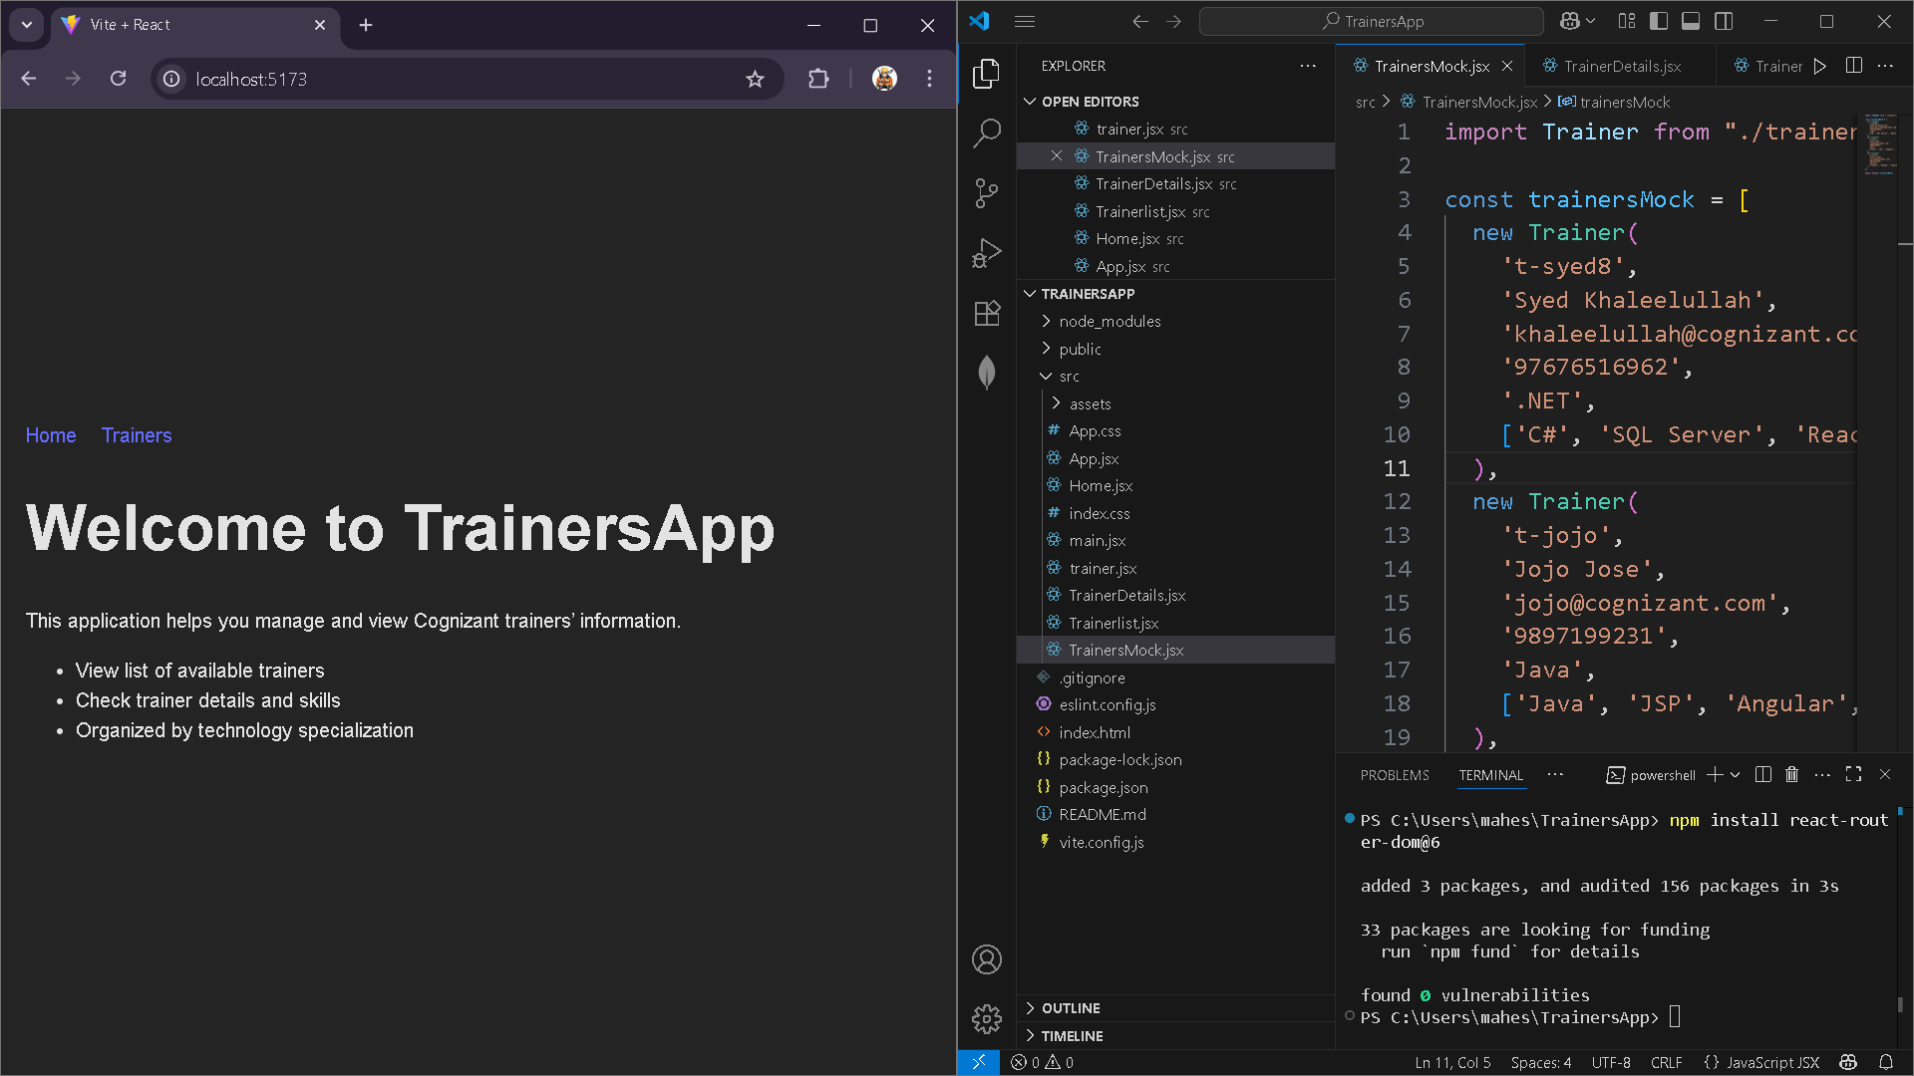

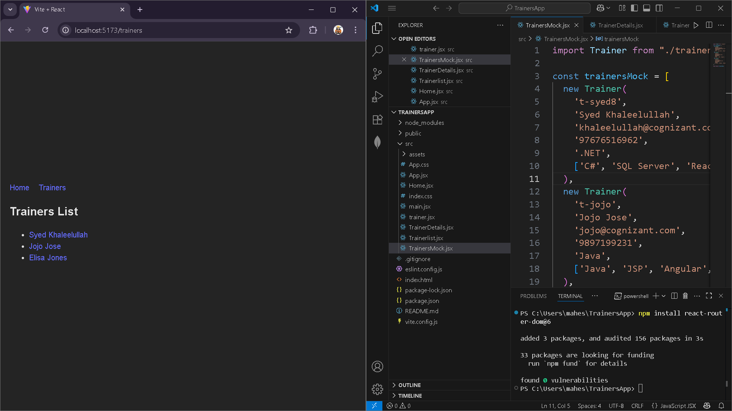

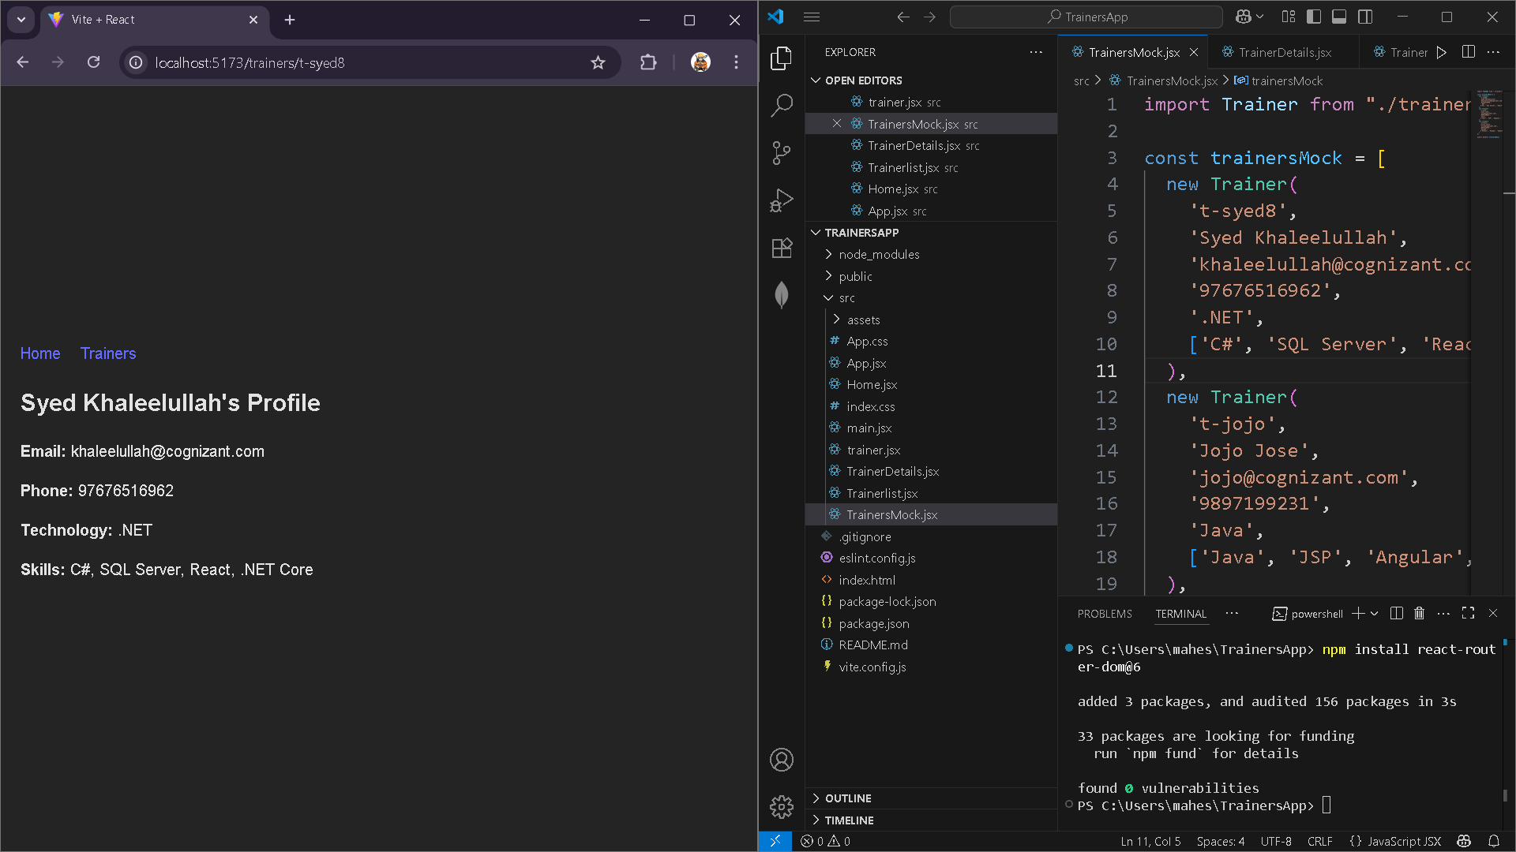

**7) ShoppingApp**

App.jsx

import React from 'react';

import OnlineShopping from './OnlineShopping';

function App() {

  return (

    <div>

      <OnlineShopping />

    </div>

  );

}

export default App;

Cart.jsx

import React from 'react';

class Cart extends React.Component {

  render() {

    return (

      <div>

        <table border="1" cellPadding="10">

          <thead>

            <tr>

              <th>Item Name</th>

              <th>Price (₹)</th>

            </tr>

          </thead>

          <tbody>

            {this.props.item.map((item, index) => (

              <tr key={index}>

                <td>{item.itemname}</td>

                <td>{item.price}</td>

              </tr>

            ))}

          </tbody>

        </table>

      </div>

    );

  }

}

export default Cart;

OnlineShopping.jsx

import React from 'react';

import Cart from './Cart';

export class OnlineShopping extends React.Component {

  render() {

    const CartInfo = [

      { itemname: "Laptop", price: 80000 },

      { itemname: "TV", price: 12000 },

      { itemname: "Washing Machine", price: 50000 },

      { itemname: "Mobile", price: 30000 },

      { itemname: "Fridge", price: 70000 }

    ];

    return (

      <div className="mydiv">

        <h1>Items Ordered :</h1>

        <Cart item={CartInfo} />

      </div>

    );

  }

}

export default OnlineShopping;

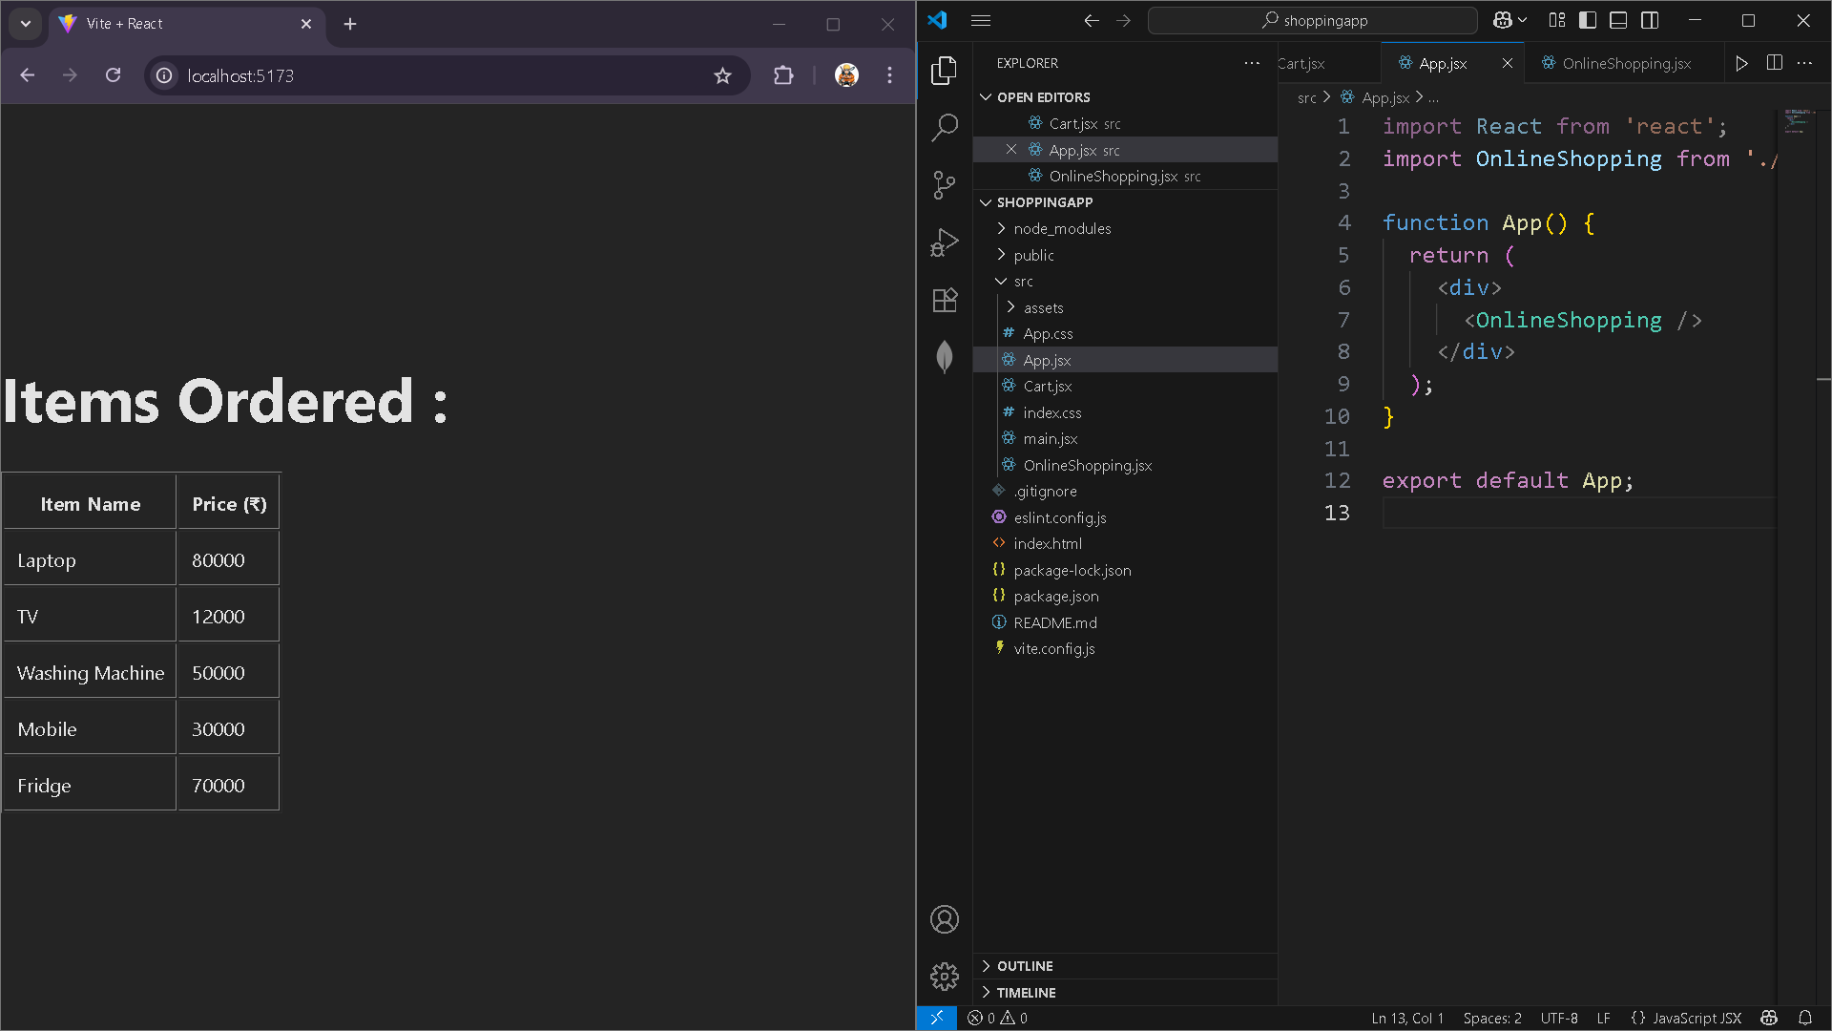

**8) CounterApp**

Countpeople.jsx

import React from 'react';

class CountPeople extends React.Component {

  constructor(props) {

    super(props);

    this.state = {

      entryCount: 0,

      exitCount: 0

    };

  }

  // Method to update entry count

  UpdateEntry = () => {

    this.setState((prevState) => ({

      entryCount: prevState.entryCount + 1

    }));

  };

  // Method to update exit count

  UpdateExit = () => {

    this.setState((prevState) => ({

      exitCount: prevState.exitCount + 1

    }));

  };

  render() {

    return (

      <div style={{ padding: '20px', fontFamily: 'Arial' }}>

        <h2>Mall People Counter</h2>

        <p><strong>People Entered:</strong> {this.state.entryCount}</p>

        <p><strong>People Exited:</strong> {this.state.exitCount}</p>

        <button onClick={this.UpdateEntry} style={{ marginRight: '10px' }}>

          Login

        </button>

        <button onClick={this.UpdateExit}>

          Exit

        </button>

      </div>

    );

  }

}

export default CountPeople;

